World dinner app

This document contains a description of “World dinner app”.

Idea:

Basically students post the picture of food they brought with description of food and its name through some form. This post suppose to be stored in database so the others can see it. Participants of the contest can give up to 3 likes and at the end the competitor with the most likes will win.

Requirements that might make problem for first version:

Posting pictures might be a problem because the website supposed to access file system or the camera of the device so it can be able to put picture in database.

Problems needed to be discussed for the next version:

Who is able to post a food in the contest?

In the first version anyone will be able to do that and that is not the best and safest solution however forcing users to register in order to be able to make a food post in the contest might be tiring for users and maybe over complicating the thing.

Design:

Here are pictures screens pages wich this website suppose to contain. Every screen is explained with its purpose and how does it works.

**-Index page:**

This is first page which will be accessible to everyone. Over here users need to enter the pin/number of the game the user wants to join which is similar concept to kahoot. At the bottom is as well link in case users want to start and create their own game session.

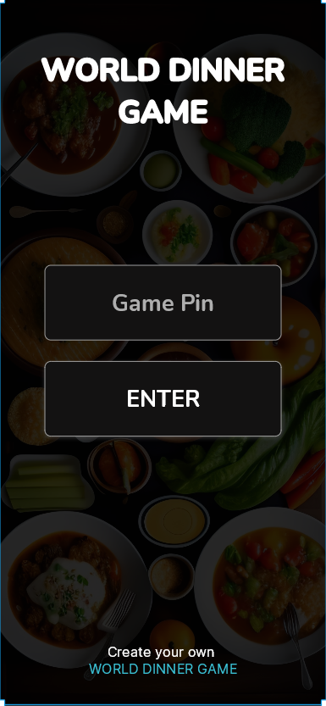

**-Registering for game/contest session:**

After entering number of the game you need to fill in some data to be ready to join it.

There are 2 roles which can join the game:

1. Just a person who is testing the food.

requirements to register:

-needs only nickname

1. User who is competing(brought his own food)

requirements to register:

-needs nickname

-needs to choose the food photo and write the description of food

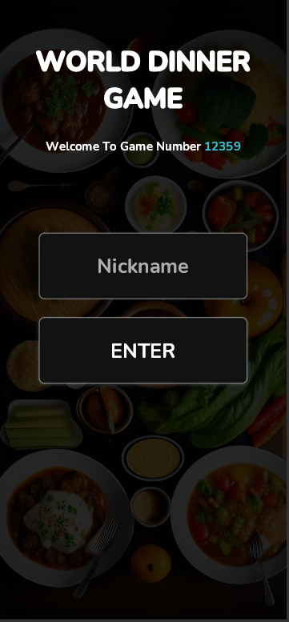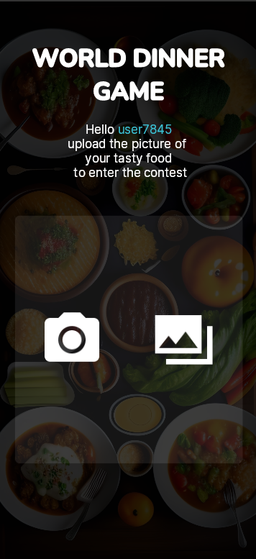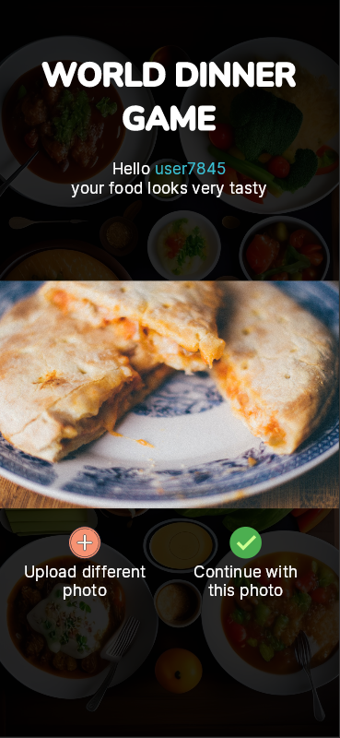

**-Contest page:**

After successful registration we are “playing the game”. Every user is able to give up to 3 likes. Basically is just like scrolling a instagram feed with restriction to give only up to 3 likes.

